LAMP

Linux web架构：

1.LAMP

Linux+Apache+Mariadb+PHP

2.LNMP

Linux+Nginx+Mariadb+PHP

# 实验：yum构建LAMP+wordpress网站

1.yum安装LAMP

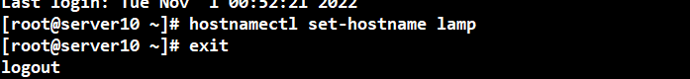

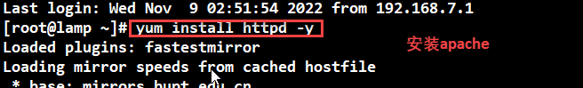

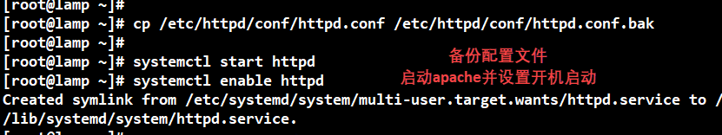

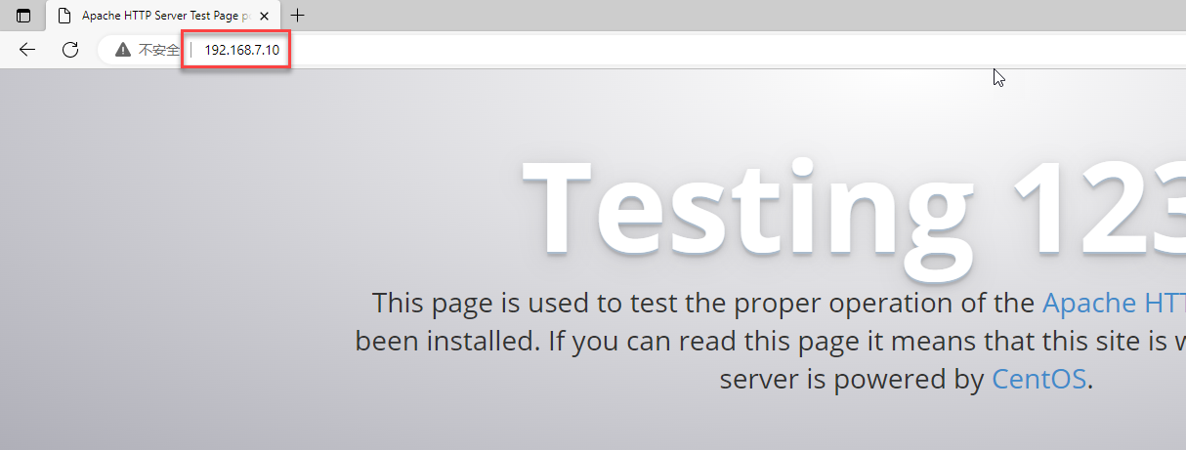

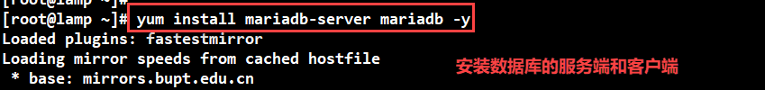

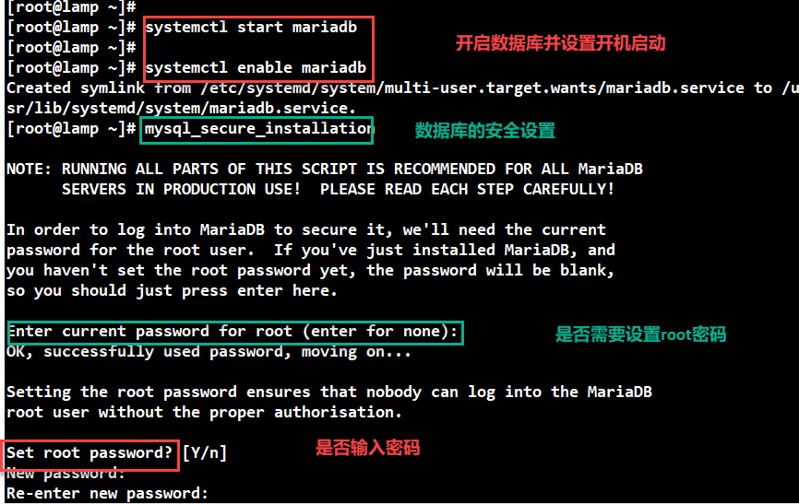

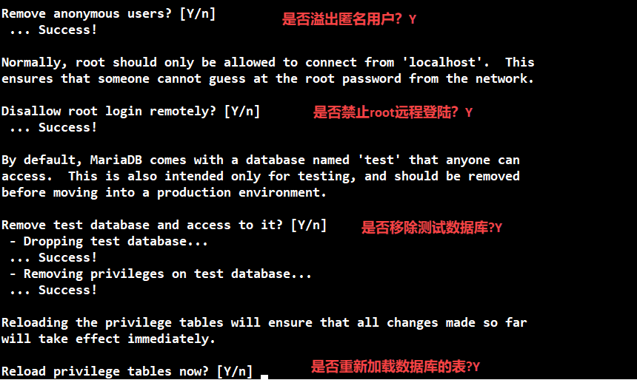

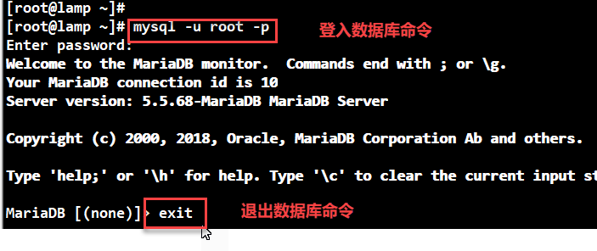

**安装PHP：**

**yum install -y php php-gd php-ldap php-odbc php-pear php-xml php-xmlrpc php-mbstring php-snmp php-soap curl curl-devel php-bcmath**

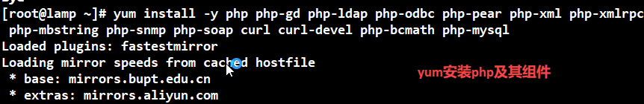

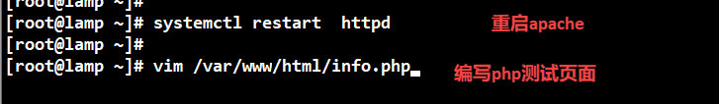

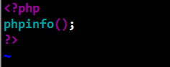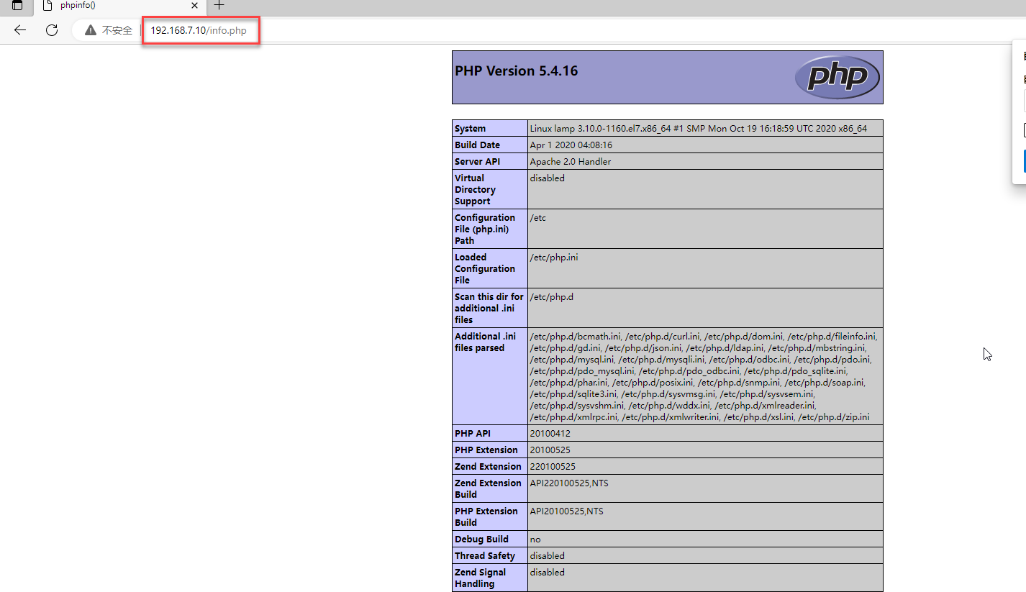

**安装和配置mariadb数据库，root是数据库的管理员密码**

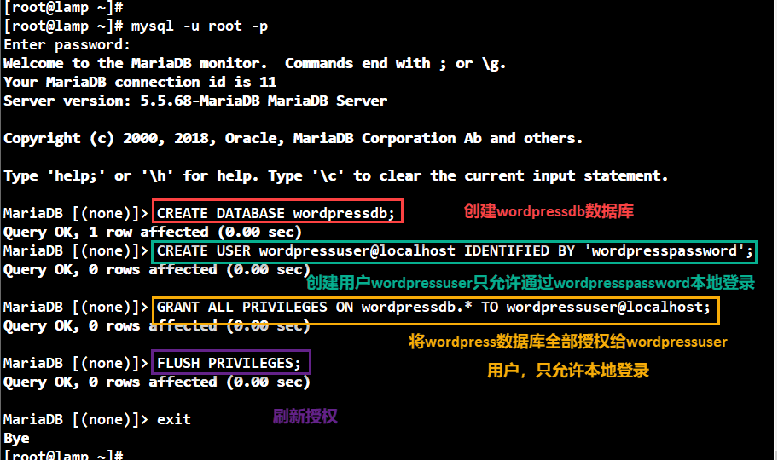

**设置防火墙规则：**

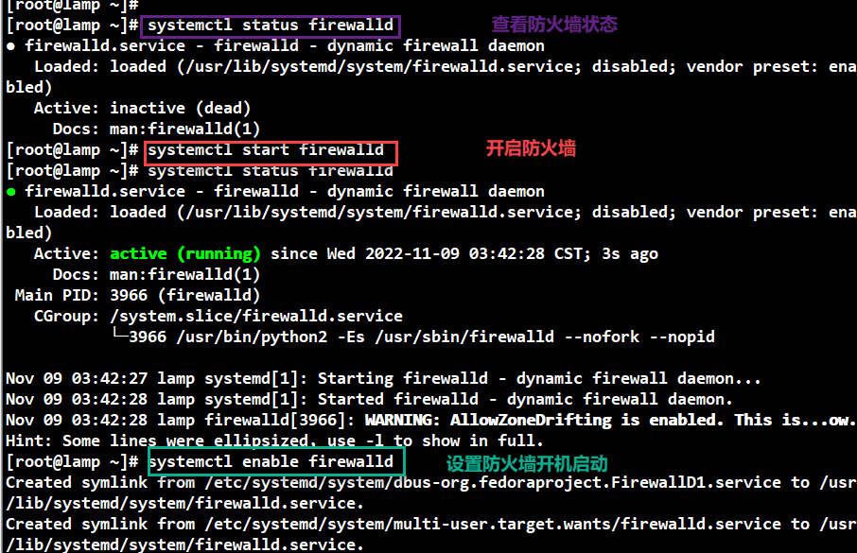

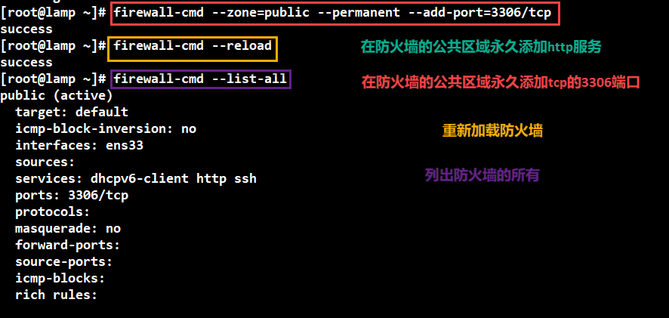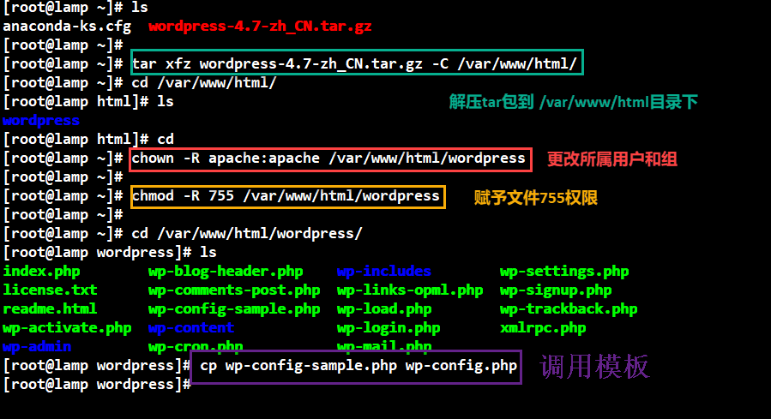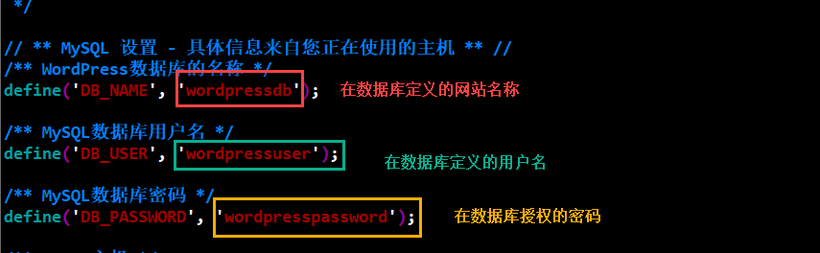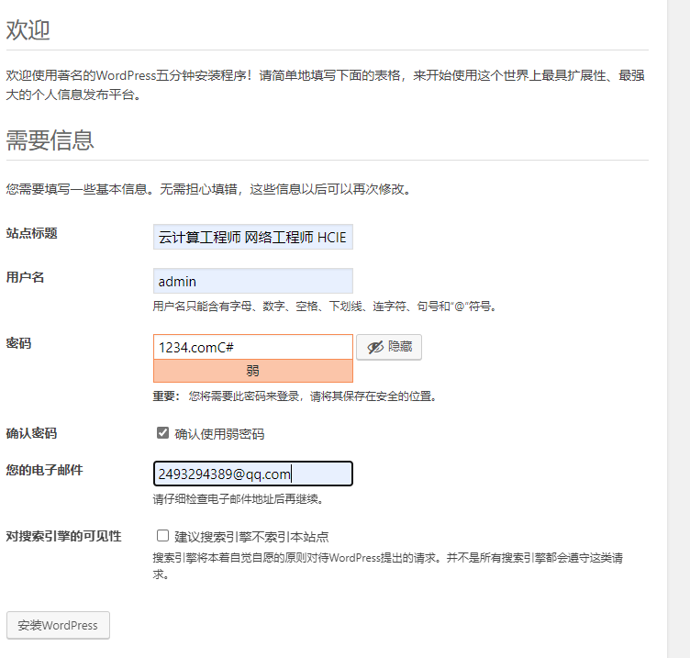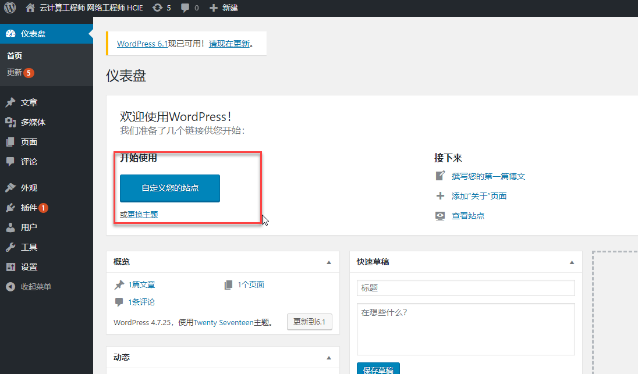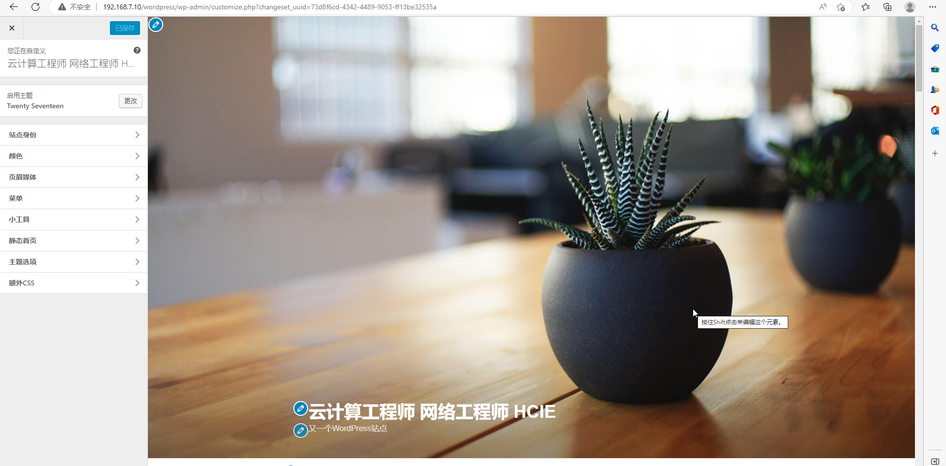

# 实验2：DNS服务器+wordpress网站

实验目的：用域名解析wordpress网站

www.benet.com直接访问wordpress网站

1.在DNS服务器上配置正向解析和方向解析

[root@ns ~]# vim /var/named/benet.com

$TTL 86400

@ IN SOA ns.benet.com. root.benet.com. (

2022110716

3H

15M

1W

1D

)

@ IN NS ns.benet.com.

ns IN A 192.168.7.11

www IN A 192.168.7.10

[root@ns ~]# vim /var/named/7.168.192.zone

$TTL 86400

@ IN SOA ns.benet.com. root.benet.com. (

2022110716

3H

15M

1W

1D

)

IN NS ns.benet.com.

10 IN PTR www.benet.com.

2.修改apache的配置文件httpd.conf,创建www.benet.com虚拟主机

<VirtualHost 192.168.7.10:80>

ServerName www.benet.com

DocumentRoot /var/www/html/wordpress

</VirtualHost>

# DocumentRoot "/var/www/html" 注释掉

3.访问测试

[www.benet.com](http://www.benet.com)

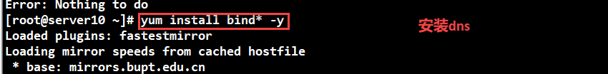

Vim /etv/name.conf 编辑主配置文件

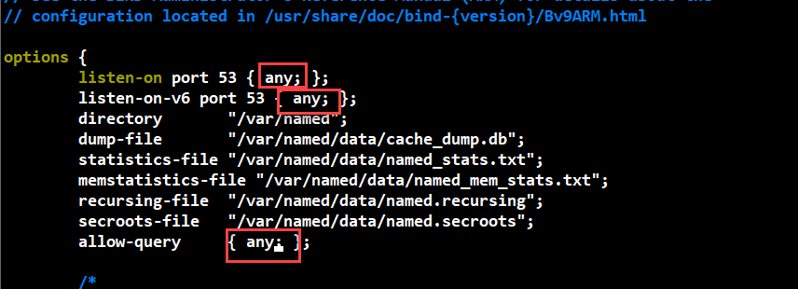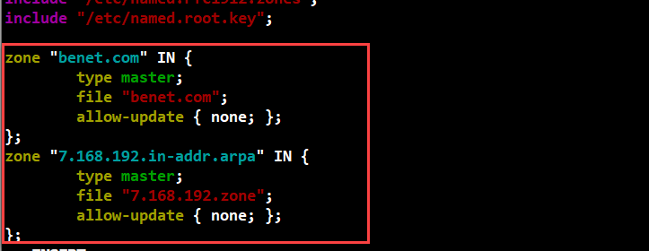

**1.在DNS服务器上配置正向解析和方向解析**

[root@ns ~]# vim /var/named/benet.com

$TTL 86400

@ IN SOA ns.benet.com. root.benet.com. (

2022110716

3H

15M

1W

1D

)

@ IN NS ns.benet.com.

ns IN A 192.168.7.11

www IN A 192.168.7.10

[root@ns ~]# vim /var/named/7.168.192.zone

$TTL 86400

@ IN SOA ns.benet.com. root.benet.com. (

2022110716

3H

15M

1W

1D

)

IN NS ns.benet.com.

10 IN PTR www.benet.com.

